Access system：

<http://127.0.0.1:8201/webapp/bank>

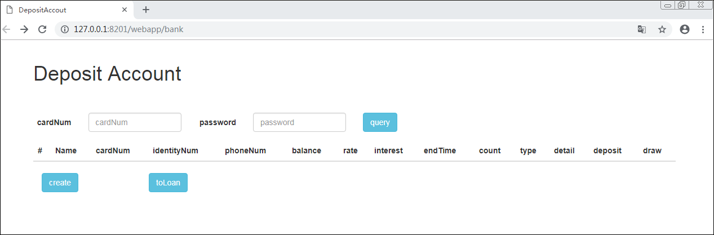

Create accout

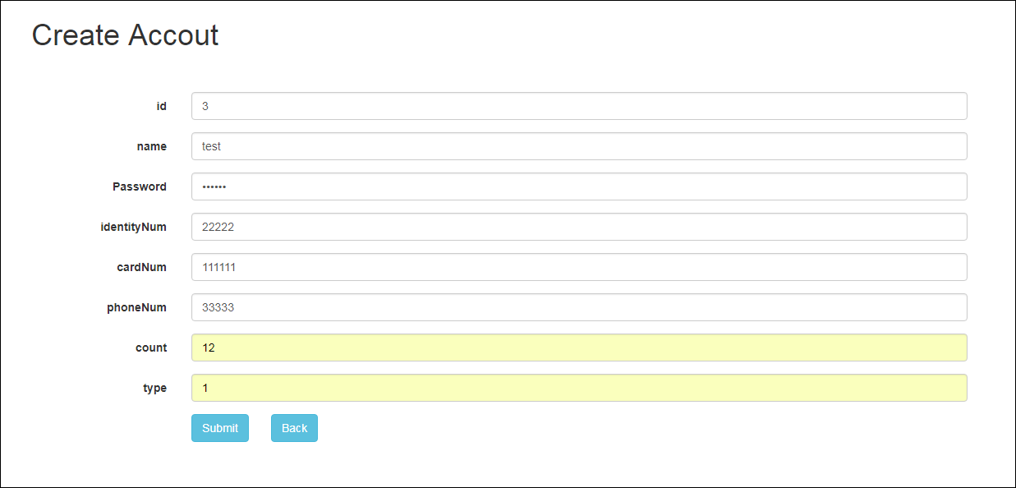

Query accout:

Input cardNum and password，do query

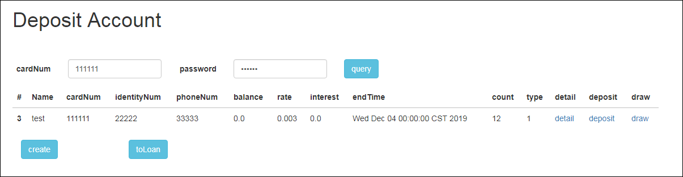

Deposit

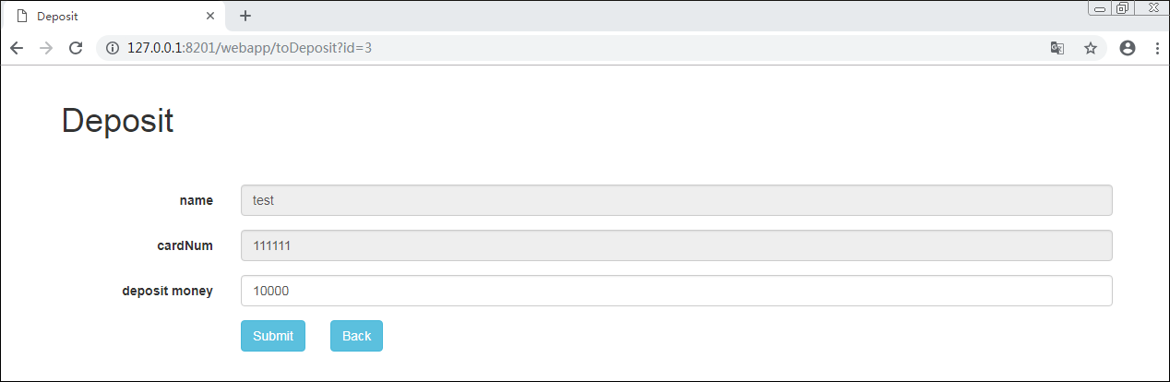

Draw Money:

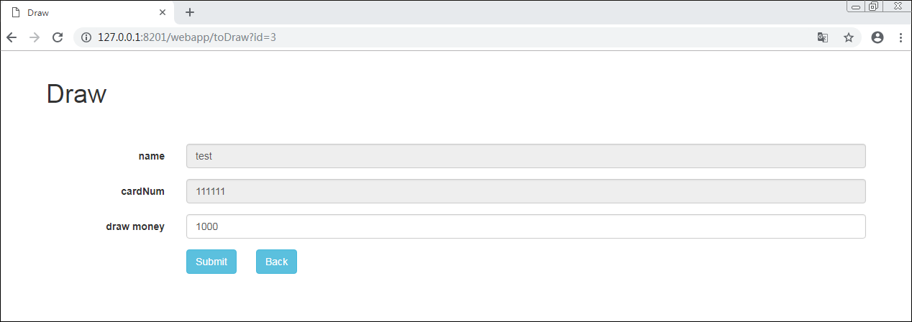

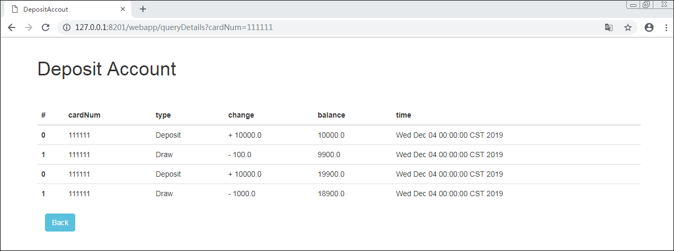

To Loan

Query Loan Accout by user identity num or card num

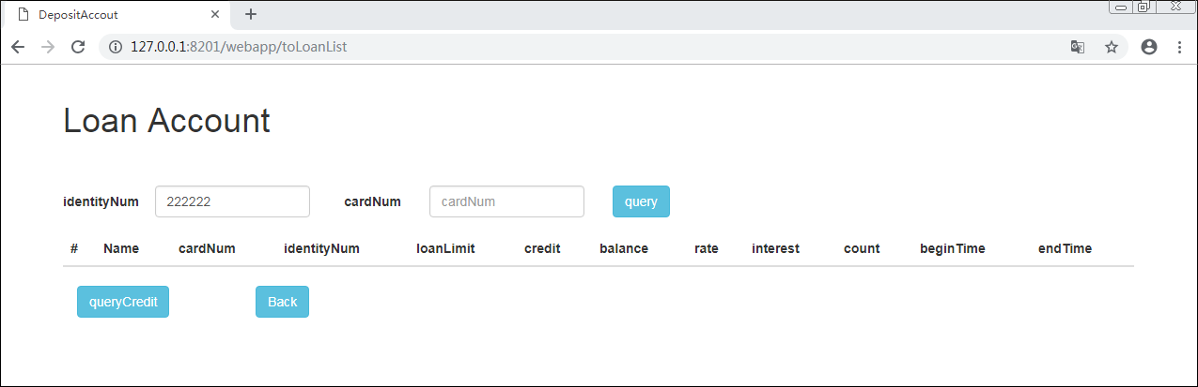

Result is:

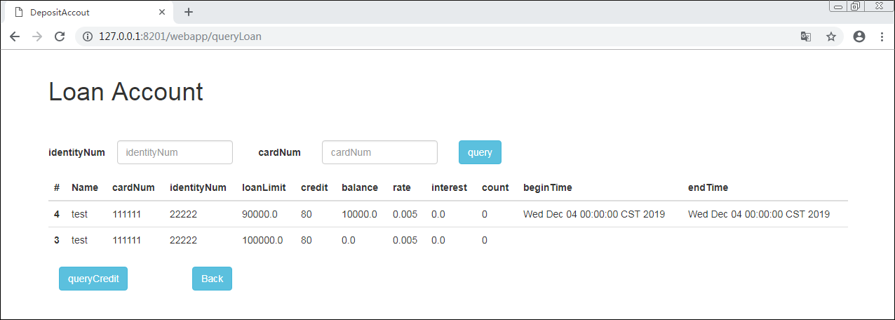

Query user Credit and Loan:

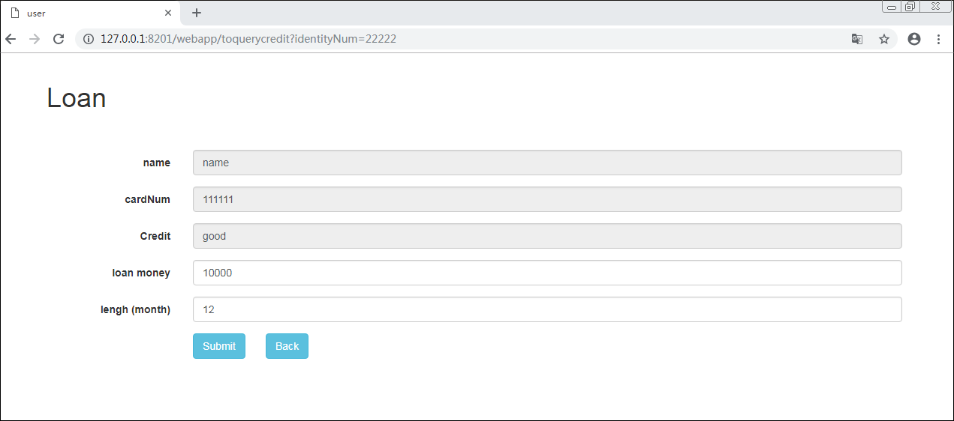

Accout Details

